**Writeup for Musical Notes:**

In the question we have been given an Image of Musical notes. On searching we get to know it is Acéré Cipher. Also hint given in this question states that it is Acéré Cipher.

Hint: All Chores Encloses Rare Encryption cipher.

Joining first letter of all works except cipher gives us idea that it is Acéré cipher.

Decoding image with Acéré Cipher give a random string.

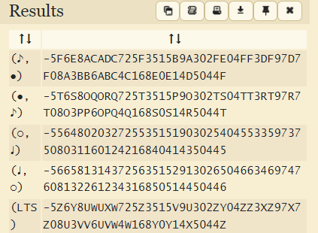

Taking the first one as its default.

Decoded String becomes

5F6E8ACADC725F3515B9A302FE04FF3DF97D7F08A3BB6ABC4C168E0E14D5044F

Now as Stated in Question Description, there was SEA of images.

In this SEA is highlighted, cracking it we can get to know it’s something related to AES also there’s a string given in question, i.e., listentocoolsong.

It is visible that length of this string is 16 which makes sense for and AES Decryption.

Hence doing Decryption using AES we can get Flag.

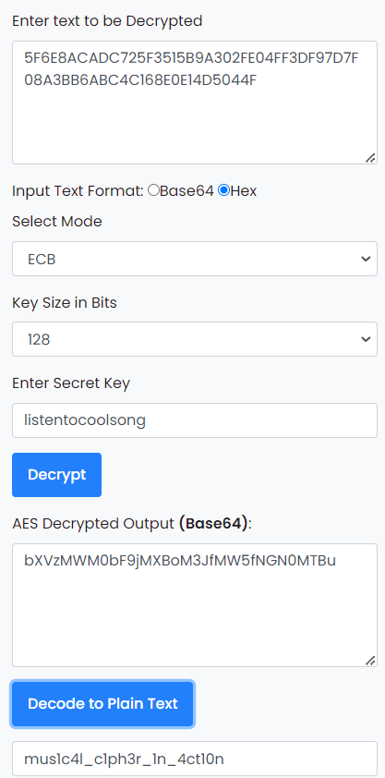

Flag: vishwaCTF{mus1c4l_c1ph3r_1n_4ct10n}